CSC 455: Database Processing for Large-Scale Analytics

Assignment 2

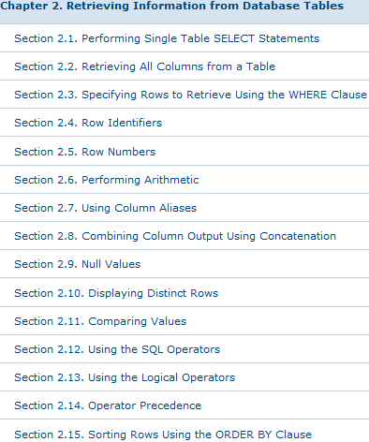
Due 11:59pm, Wednesday, October 9th.

Supplemental reading: SQL reference book Oracle 11g SQL by Price, ISBN 9780071498500 (available in Books 24x7 DePaul online library as eBook). Sections 2.1 – 2.3, 2.6, 2.9 – 2.15 (section names are included in the screenshot→)

Python for Data Analysis, pp174 “Interacting with Databases”

You can read Chapter 6: Database Design Using Normalization in “Databases: A Beginner’s Guide” by Andrew Oppel, ISBN 0071608478 in the online library if you would like a book-based reference for normalization material.

Part 1

You are given a following schema (First, Last, Address, Job, LNumber, Interest, Amount) and the following set of functional dependencies:

First, Last → Address
LNumber → Interest, Amount
(remember that underlined primary key implies First, Last, Job, LNumber →Address, Interest, Amount)

Decompose the schema to make sure it is in Third Normal Form (3NF).

Write SQL DDL and SQL INSERT statements to create the 3NF tables and load the data provided in the text file data_hw2.txt (posted in the documents section on COL). Note that NULL is supposed to represent database NULL – in some cases NULL may be represented by another special symbol to distinguish it from the ‘NULL’ string.

Part 2

Write a python script that is going to load your tables from Part 1 and populate them with data automatically. Use sqlite3 database and make the necessary data type changes (NUMBER(5,0)→INTEGER, NUMBER(5,2)→REAL).

You can use the following sample code for reading the input file and iterating through every line (just be sure that the file is in the local directory or specify the full path):

fd = open('data_hw2.txt', 'r')
data = fd.readlines()
fd.close()

for elt in data:
print "Row ", elt

For this assignment, do not worry about error checking. You could use a dictionary to collect data list for each table first and then use executemany function. However, for this assignment, you can simply write python code that will iterate over all rows in the table and perform separate insert into every table in the schema as it goes along (ignoring errors that will result from attempts at inserting a duplicate key).

Part 3

You were hired to do some data analysis for a local zoo. Below is the data table, including the necessary constraints and all the insert statements to populate the database.

-- Drop all the tables to clean up
DROP TABLE Animal;

-- ACategory: Animal category 'common', 'rare', 'exotic'. May be NULL
-- TimeToFeed: Time it takes to feed the animal (hours)
CREATE TABLE Animal
(
AID NUMBER(3, 0),
AName VARCHAR2(30) NOT NULL,
ACategory VARCHAR2(18),

TimeToFeed NUMBER(4,2),

CONSTRAINT Animal_PK
PRIMARY KEY(AID)
);

INSERT INTO Animal VALUES(1, 'Galapagos Penguin', 'exotic', 0.5);
INSERT INTO Animal VALUES(2, 'Emperor Penguin', 'rare', 0.75);

INSERT INTO Animal VALUES(3, 'Sri Lankan sloth bear', 'exotic', 2.5);
INSERT INTO Animal VALUES(4, 'Grizzly bear', 'common', 3.0);
INSERT INTO Animal VALUES(5, 'Giant Panda bear', 'exotic', 1.5);
INSERT INTO Animal VALUES(6, 'Florida black bear', 'rare', 1.75);

INSERT INTO Animal VALUES(7, 'Siberian tiger', 'rare', 3.5);
INSERT INTO Animal VALUES(8, 'Bengal tiger', 'common', 2.75);
INSERT INTO Animal VALUES(9, 'South China tiger', 'exotic', 2.25);

INSERT INTO Animal VALUES(10, 'Alpaca', 'common', 0.25);
INSERT INTO Animal VALUES(11, 'Llama', NULL, 3.5);

Since none of the managers in the zoo know SQL, it is up to you to write the queries to answer the following list of questions.

- Find all the animals (their names) that take less than 2 hours to feed.

- Find all the rare animals and sort the query output by feeding time (any direction)

- Find the animal names and categories for the animals that are related to a bear (hint: remember the LIKE operator)

- Return the listings for all animals whose rarity is not available in the database

- Find the rarity rating of all animals that require between 1 and 2.2 hours to be fed

- Find the names of the animals that are related to the tiger and are not common

- Find the minimum and maximum feeding time amongst all the animals in the zoo

- Find the average feeding time for the rare animals

Be sure that your name and “Assignment 2” appear at the top of your submitted file.

